Questions & Answers 001 for compiler course
Teacher: Lin Yi , School of Computer Science, Northwestern Polytechnical University
- mail: ly_cs@nwpu.edu.cn
Mobile Phone: 13572591128
Date: May. 15, 2022

Part 01

Content
Question & Answer 2
【Q1】left-most derivation, syntax tree 2
【Q 2】Ambiguous / Syntax Tree, etc. 2
【Q3】Write BNF syntax rules from given language 2
【Q4】Write BNF from language 2
【Q5】Eliminate left recursive and left factor 3
【Q6】LL(1) parsing table，First/Follow set 3
【Q7】LL(1) and ambiguous 3
【Q8】Left recursive grammar must not be LL(1) 3
【Q9】Left factor and LL(1) 3

Question

【Q1】left-most derivation, syntax tree
【Q1】Given G[E]：
E->TE’ E’->ATE’ | ε T->FT’
T’->MFT’ | ε F->(E) | i
A->+ | - M->* | /
Give the left-most derivation sequence for i+i*i
Compute the First Set, Follow Set and LL(1) Table.
Then give the LL(1) table based left-most derivation for (i+i)*i
From the steps of above derivation from,
write the syntax tree that could represent ( i + i ) MFT’E’

Solution:

【Q 2】Ambiguous / Syntax Tree, etc.
【Q2】Given G[E]
E -> E op E | ( E ) | int
op -> + | - | * | /
int -> 0 | 1 | ... | 9
Judge whether G[E] is ambiguous. Give two different reasons.
For string 10-2*5, two different syntax tree could be left-most derived.
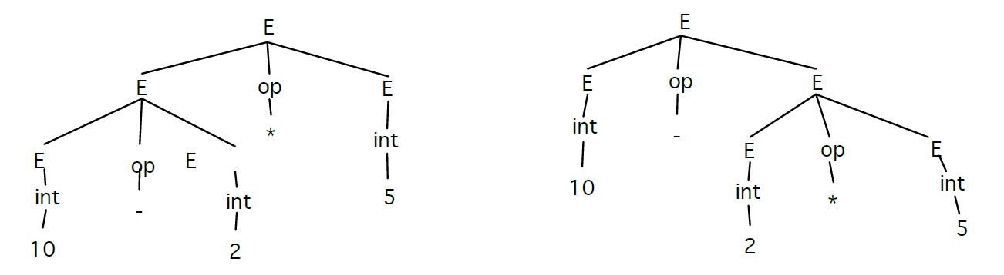
Give your computation sequence for the two trees.

【Q3】Write BNF syntax rules from given language
【Q3】Given language as { a^{n}b^{n}c^{m}|n>=1，m>=0}, write BNF syntax rules.

【Q4】Write BNF from language
【Q4】Suppose a language contains all positive even integers ( 0, 2, 4, 6, 8, ...)
Write BNF for the above language supposing that the number could begin with number 0 ---- e.g: 03, 09 is allowed.
If all number could not begin with 0. Write BNF.

【Q5】Eliminate left recursive and left factor
【Q5】Given G[A]：
A->Ba | ed
B->Bac | edc | ggA |eA
Please eliminate direct left recursive and left factor.

【Q6】LL(1) parsing table，First/Follow set
【Q6】Given G[S]：
S→XY
X→Ya｜ε
Y→Zb｜Z
Z→d｜ε
Calculate First set, Follow set and LL(1) parsing table. Then judge whether the syntax is or is not LL(1) grammar.

【Q7】LL(1) and ambiguous
【Q7】Given G[S]：
S->if e then S | if e then S else S
Eliminate left recursive and get G’[S]：
S->AB
A->if e then S
B->else S | ε
（1）Write the First set Follow Set and LL(1) table for G’[S].
（2）Judge if it is LL(1).
（3）Is the grammar ambiguous?

【Q8】Left recursive grammar must not be LL(1)
【Q8】Proof the conclusion: if a grammar has left recursive, it must not be LL(1) grammar.

【Q9】Left factor and LL(1)
【Q9】Proof: grammar containing left factor must not be LL(1)

